- U.S. Labs manufactures mechanical heart valves from the heart valves of pigs. Different heart operations require valves of different sizes. U.S. Labs purchases pig valves from three different suppliers. The cost and size mix of the valves purchased from each supplier are given in Table 3. Each month, U.S. Labs places one order with each supplier. At least 500 large, 300 medium, and 300 small valves must be purchased each month. Because of limited availability of pig valves, at most 700 valves per month can be purchased from each supplier. Formulate an LP that can be used to minimize the cost of acquiring the needed valves.

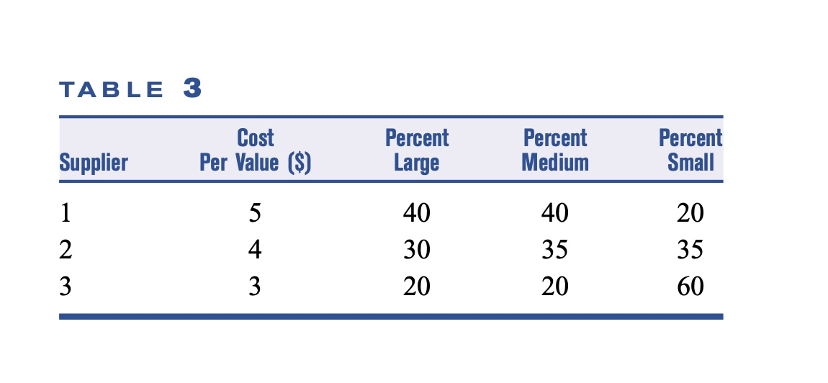

- A firm producing a single product has three plants and four customers. The three plants will produce 3,000, 5,000, and 5,000 units, respectively, during the next time period. The firm has made a commitment to sell 4,000 units to customer 1, 3,000 units to customer 2, and at least 3,000 units to customer 3. Both customers 3 and 4 also want to buy as many of the remaining units as possible. The profit associated with shipping a unit from plant i to customer j is given in Table 82. Formulate a balanced transportation problem that can be used to maximize the company’s profit.

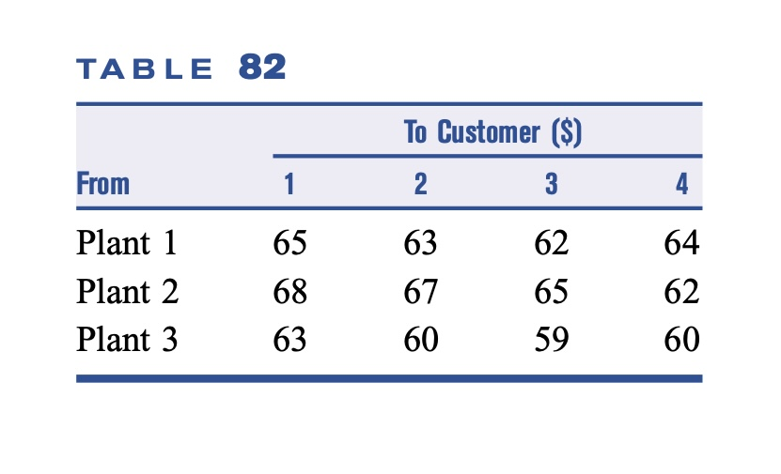

- A company can produce as many as 35 units/month. The demands of its primary customers must be met on time each month; if it wishes, the company may also sell units to secondary customers each month. A $1/unit holding cost is assessed against each month’s ending inventory. The relevant data are shown in Table 83. Formulate a balanced transportation problem that can be used to maximize profits earned during the next three months.

